DAY 3 – API INTEGRATION AND DATA MIGRATION

The focus for Day 3 is integrating APIs and migrating data into Sanity CMS to build a functional Marketplace backend. Students will learn how to utilize APIs for reference, migrate data into Sanity CMS, and ensure compatibility with their templates. This approach replicates real-world practices and prepares students to handle diverse client requirements, including integrating headless APIs or migrating existing data from popular eCommerce platforms.

Document Title : DAY 3 – API Integration Report – [ KOUNAIN Ecommerce]

What to Submit:0

A report documenting:

*API integration process.

*Adjustments made to schemas.

*Migration steps and tools used.

Screenshots of:

*API calls.

*Data successfully displayed in the frontend.

*Populated Sanity CMS fields.

*Code snippets for API Integration and migration scripts.

SCREENSHOTS ARE BELOW:

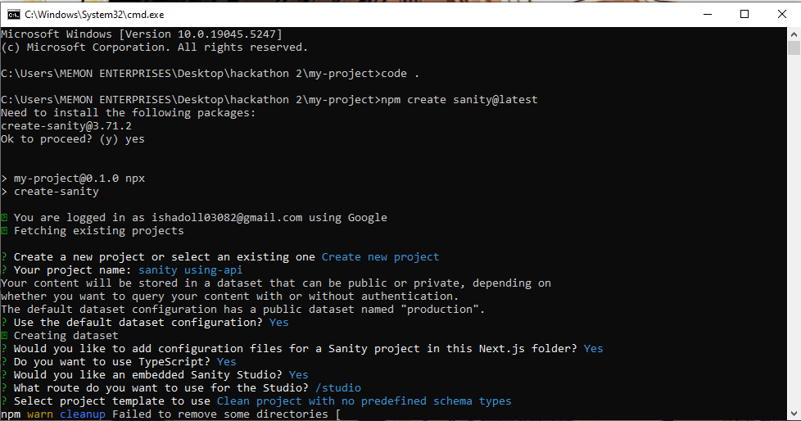

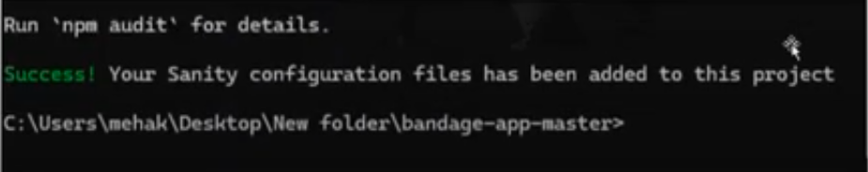

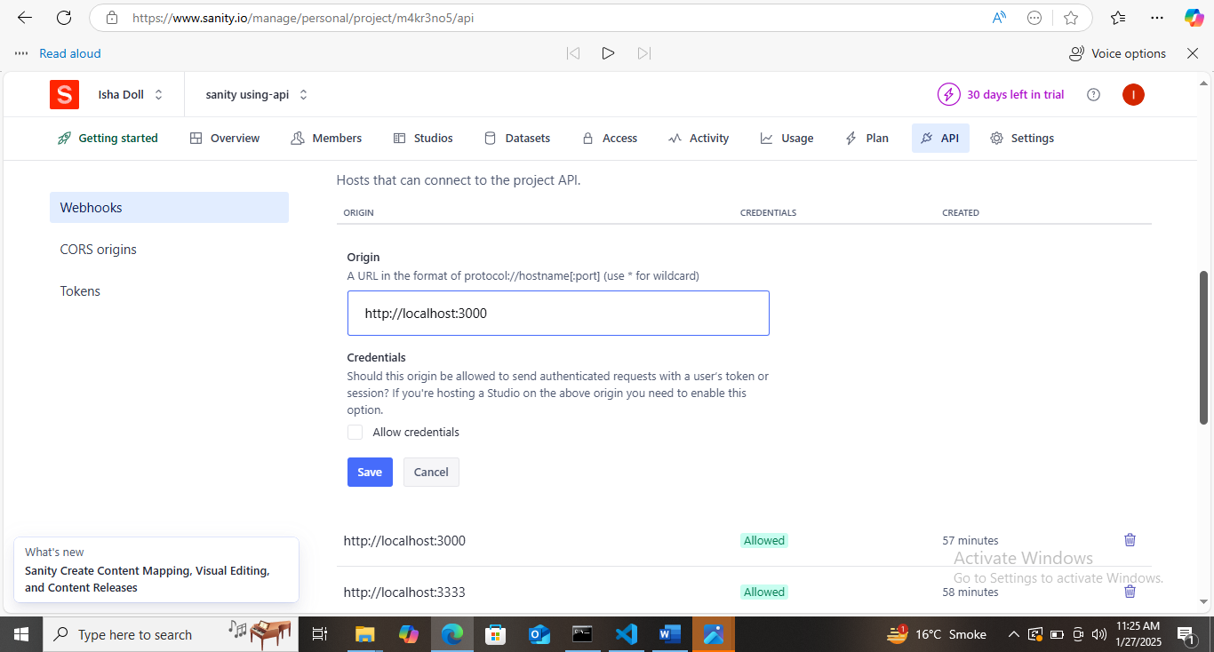

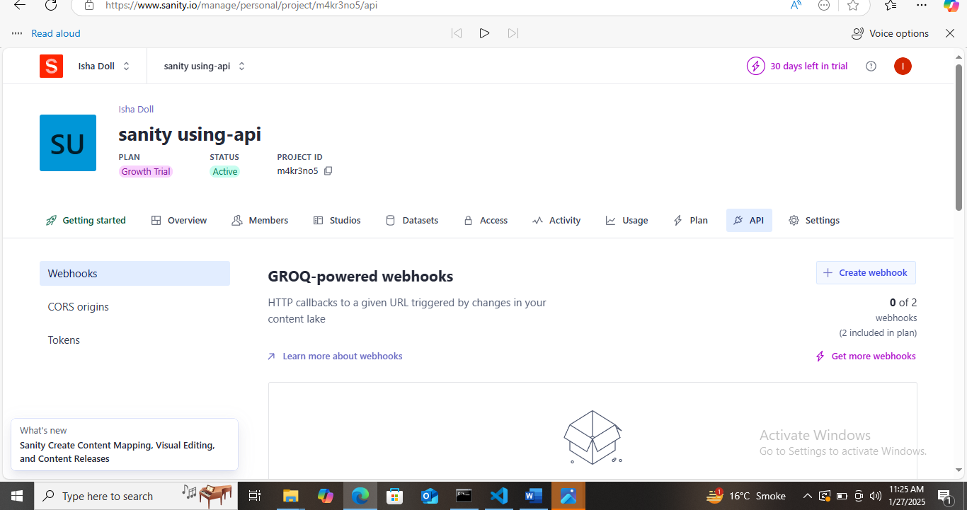



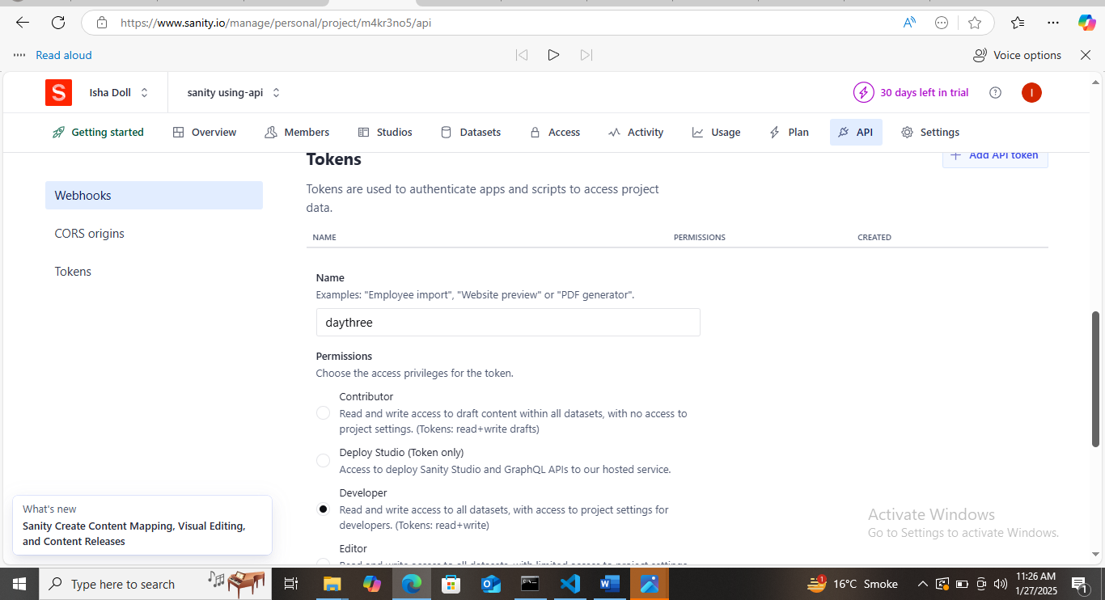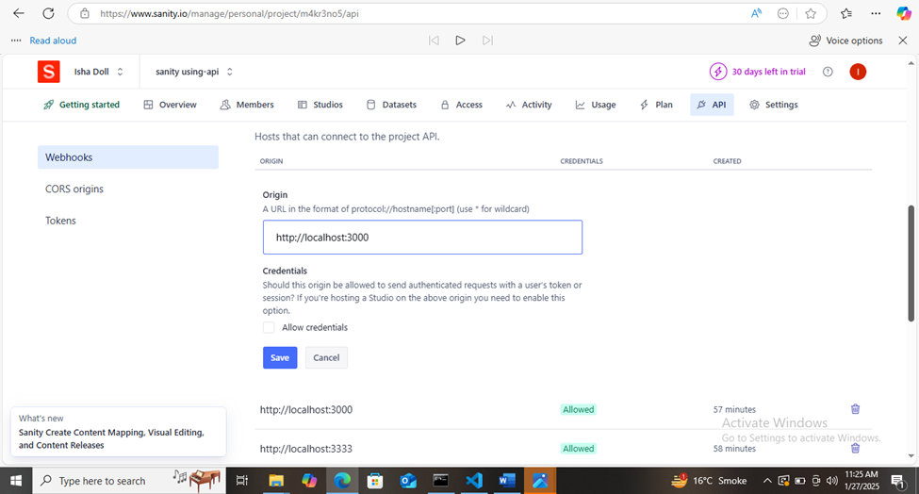

Product schemas:

# Included images with manual uploads:

Category schemas:

# *Updated categories menu to a custom site relevant to local drop shipping.

# *Usage of regional languages in category descriptions.

# **Migration Steps and Tools Used**

Steps**:**

**1.Data Export.**

**2.Data Cleaning.**

**3.Schema Mapping.**

**4.Manual Entry into Sanity.**

**5.Validation.**

**Tools used:**

**\*Excel/Google Sheets.**

**\*Sanity CMS Dashboard.**

1.API Calls:

Data was exported and entered.

## 2.Data successfully Displayed in the Frontend.

3.Populated CMS Sanity Fields.

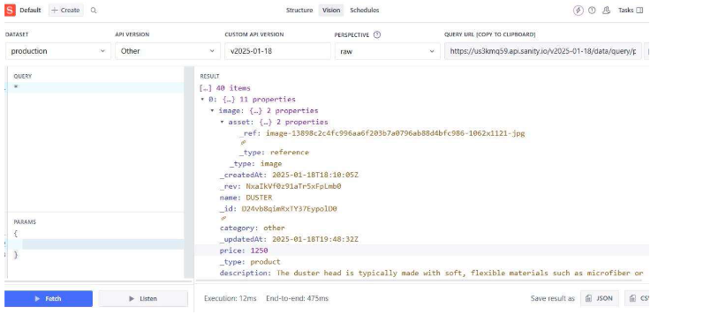

**Code Snippets for API Integration and Migration Scripts.**

#### API Integration:

Data export was performed so no need of code for API Integration.

### 4.Example Code for Frontend Integration:

#### Example Migration Script:

Data was entered so no migration script was used.

#### Self-Validation Checklist:

*API Understanding

*Schema Validation

*Data Migration

*API Integration in Next.js

Submission Preparation

*Data successfully fetched and displayed in Sanity CMS.

*Frontend validated with manually entered data.

*Screenshots must be attached.

Conclusion:

This report includes data migration and integration with Sanity CMS for Media Mart Teams, ensuring experience for local drop shipping in Pakistan.

Prepared by:

KOUNAIN AFTAB.